Summer Worship Series
The Inventions of Summer
“There is no end, believe me! to the inventions of summer…” -Mary Oliver, The Roses
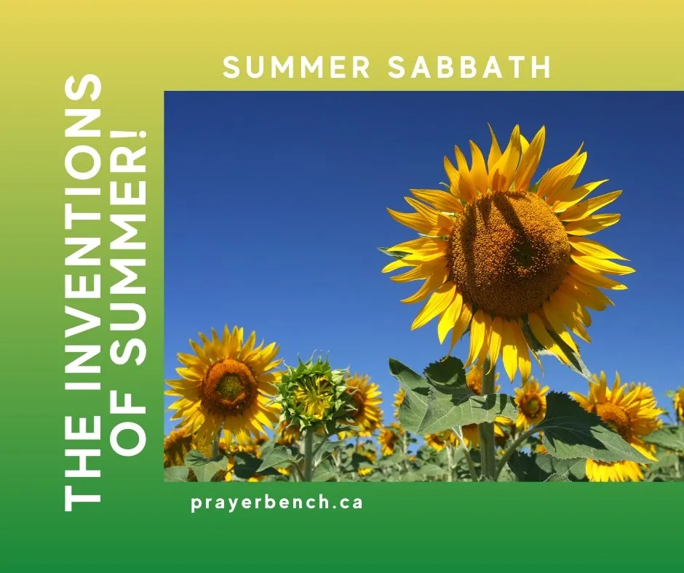

Worship Title: STRING BEANS
Taking Up the Offerings
Invitation to Gather & Candle Lighting
In this season of long light and growing things,
we gather in the presence of the Holy.
We come to notice, to listen, to pray.
In the quiet work of creation, God is near—
in what delights us,
and in what troubles us.
God meets us here, in the ordinary.
In the gifts of the earth, creation teaches us gratitude.
(Light the candle.)
We open our hearts—
to wonder, to wisdom, to the Spirit’s gentle leading.
So, we worship.

Opening Prayer
Maker of all that grows and breathes,
we come to you
in the beauty, the abundance,
and even in the disturbances of life.
Open us to your presence in the ordinary.
Open our hearts to receive what the moment teaches.
Open our lives to become a blessing in the world.
In this time, may string beans
teach us your way—
the way of praise,
the way of gratitude,
the way of compassion,
the way of faithful prayer.
We come in wonder, in honesty, in hope. Amen.
Scripture Reading
Colossians 3:12-17
Colossians 3:12-17 from the New Living Translation (NLT):
12 Since God chose you to be the holy people he loves, you must clothe yourselves with tenderhearted mercy, kindness, humility, gentleness, and patience. 13 Make allowance for each other’s faults, and forgive anyone who offends you. Remember, the Lord forgave you, so you must forgive others. 14 Above all, clothe yourselves with love, which binds us all together in perfect harmony. 15 And let the peace that comes from Christ rule in your hearts. For as members of one body you are called to live in peace. And always be thankful. 16 Let the message about Christ, in all its richness, fill your lives. Teach and counsel each other with all the wisdom he gives. Sing psalms and hymns and spiritual songs to God with thankful hearts. 17 And whatever you do or say, do it as a representative of the Lord Jesus, giving thanks through him to God the Father

“And let the peace of Christ rule in your hearts,
to which indeed you were called in the one body.
And be thankful.” -- Colossians 3:15

PAUSE FOR REFLECTION
Is there anything more lovely in summer than the first taste of string beans?
But before that, there is planting the seed. Do you remember the school project
sprouting the plump seeds between two pieces of damp paper towel? Then planting
one or two in a tiny pot? And then the waiting.
String beans are easy to grow and one of the most frequently prepared summer
vegetables. Hot, cold, and even raw, string beans are versatile in the kitchen.
Harvesting green beans is an ongoing task and there is the delicious irony that the more
you pick, the more beans the plants will set. I also remember being taught not to pick
them when the plant was wet, or they would rust.
Mary Oliver writes a short essay about Beans. (If you google “Beans by Mary Oliver” you
might find it, but it is also in her book Devotions. This is one of my favourite books and
definitely on the list to take to a desert island or for anytime reading.)
Oliver reminds us that when we are picking beans we rarely think about “their
willingness for the pot, for the fire” and “the gift of their lives to assist [ours].”
“Be thankful,” says Paul in his Letter. “Be thankful.” The practice of gratitude reminds
that there are so many gifts in the world. Big gifts and small. It is worth reflecting on the
ordinary string bean and what it gives as a gift to the world.
Nurturing a heart of gratitude may help us experience positive emotions, feel more alive
in ourselves, be more compassionate to one another and kind to creation and even sleep
better. Let our prayers of thanksgiving overflow.
We honour the gifts we receive when we say thanks. But gratitude does not end with the
expression of our thanks. What comes after thanksgiving? We have a responsibility to
keep gifts in motion by giving back when we have received. Thanksgiving is something
we do. A gift asks something of us.
Consider carefully these words of Robin Wall Kimmerer, who writes of reciprocity in her
book, Braiding Sweetgrass. (Another highly recommended book for a summer reading.)
“In the teachings of my Potawatomi ancestors, responsibilities and gifts are
understood as two sides of the same coin. The possession of a gift is coupled
with a duty to use it for the benefit of all. A thrush is given the gift of song—and
so has a responsibility to greet the day with music. Salmon have the gift of travel,
so they accept the duty of carrying food upriver. So, when we ask ourselves,
what is our responsibility to the Earth, we are also asking, “What is our gift?”2
When we accept the gift of a string bean as a delightful invention of summer, we have a
responsibility in turn to offer our gift. Our first response is heartfelt thanksgiving. From
there, we keep the gift in motion by offering the unique gift we are to the world.
Imagine all the gifts in circulation in this one body of Earth. Confess how our species has
often forgotten the willingness of string bean for the pot. Look back over the day so far.
What other gifts have you forgotten?

BREATH PRAYER
“A divine voice sings through all creation.” – from a Jewish Prayer.

PRACTICE “TAKING UP THE OFFERINGS”
Find a giving position for your body. Seriously, try out a few postures and
gestures. You will know when you have found the giving gesture that is right
for you.
Hold this gesture and make silence for at least 5 minutes. Allow gifts to come
to your heart. As a gift arrives, breath in your thanks. Like this: A tree…
breathe in thanks and then let go the thought. Return to silence and receive
another gift. The gift of what you ate for lunch … breathe in thanks and then let
go the thought. Allow other gifts to come to your heart. Delight in other
inventions of summer. Accept all gifts that arise even the ones that may not
initially feel like a gift. Accept and let go with gratitude in your heart.
When your 5 minutes has passed (or however long you decide to pray) ask
yourself: What is the gift I will give today that changes the world a little bit? Notice
during the day the times you are offering gift to the world. Keep gifts in motion.
2 “Returning the Gift” by Robin Wall Kimmerer posted in the Centre for Humans and Nature, online article accessed May 2020. https://www.humansandnature.org/earth-ethic-robin-kimmerer

Reflection Option: A Gardener’s Story.
Interview a gardener using some of these questions or ones of your own:
- How did you first begin gardening? What drew you to it?
- What keeps you returning to the garden each season?
- Can you describe what it feels like to step into your garden at this time of year?
- What have string beans taught you?
- In your experience, what does it mean to tend something, rather than just grow it?
- What is it like to harvest something you’ve grown yourself?
- Do you experience the harvest as something you’ve achieved, received, or both?
- Is there a moment in the growing season when you feel especially grateful?
- Gardening isn’t just taking from the earth—how do you find yourself giving back?
- In what ways do you ever experience gardening as a form of prayer?
- Are there moments in the garden that feel especially sacred or holy?
- What is one simple way people can become more connected to the earth this summer?
- If the garden could speak to us as a community of faith, what might it say?

Prayer of the People
A Prayer of gratitude for the day so far.
God of this day and yesterday
we name in our hearts
all that unfolded:
the moments seen and unseen,
the work, the rest, the conversations.
We remember …. (Pause)
We give thanks
for small kindnesses,
for beauty glimpsed,
for strength we did not know we had.
Listen to our heartfelt thanksgiving … (shared aloud or in silence.)
For what is unfinished,
or heavy,
or uncertain
we place it in your care. (Pause)
For the concerns our community,
our community of faith,
our world,
use the willingness of our hands to help.
“What is the gift I will give today to change the world a little bit?” (Pause)
Receive our willingness,
our hopes,
our lives as they are.
Stay with us in what remains of this day,
and shape us gently in your grace. Amen.
Closing Blessing of Gratitude
As you go from this place,
may you receive what is given.
In the small harvests of your days,
in what is enough,
in what is shared,
and may you recognize the gift.
Silent Prayer
And as we have received,
we will also return blessing
to the earth,
to one another,
to the Giver of all good things. Amen.
https://vimeo.com/1172144922?fl=pl&fe=sh

